**Analyzing the relation between certain metrics and success in competitive Tagpro**

Abstract: This paper examines the competitive scene of an online, CTF-based web browser ball game called “Tagpro” and examines which stats are correlated the most closely with success, both as a defender and as an attacker. For the purposes of this analysis, success is defined as a player’s score differential per minute, calculated by [(Team captures – Opponent team captures)/Minutes]. To answer this question, we examine the stats for the 10th season of competitive play in MLTP, the most elite North America league, grouped by the position of each player (O or D). The season will be examined to determine which stats were the most related to success over time. A PLACEHOLDER model will be developed to see which factors produce the best prediction for team success for the next upcoming season. The results show that attackers who capped a lot and controlled powerups well had the most success, and defenders who had high prevent and were able to generate high slaying power from tags and returns and not dying too much to keep a reasonable KDR succeeded the most. KDR was the least important for attackers to focus on, and powerup control was the least important for defenders. From an improvement perspective, this would be indicative to players and even teams trying to elevate their game to the elite level which aspects of their game are the most vital to improve upon and which ones have relatively little impact on ability to succeed.

Methods

The data for the season was collected weekly in .csv/.tsv formats and imported into Tagpro League. Upon completion of the season, the cumulative stats for each player were downloaded as a .tsv and imported into RStudio. The data was then cleaned and sorted into two separate categories, offensive and defensive players. The correlation between success rate and each defensive statistic was calculated and graphed (including a line of best fit and a confidence interval) for the set of defensive players, and the correlation between success rate and each offensive statistic was calculated and graphed. Several other statistics are calculated and displayed for each factor, such as mean, standard deviation, variance, minimum, and maximum. Next, predictive models are built using PLACEHOLDER in the hopes that if a players stats are examined in the upcoming season, the model would accurately be able to predict the measure of success that player achieved in acquiring those stats.

Results

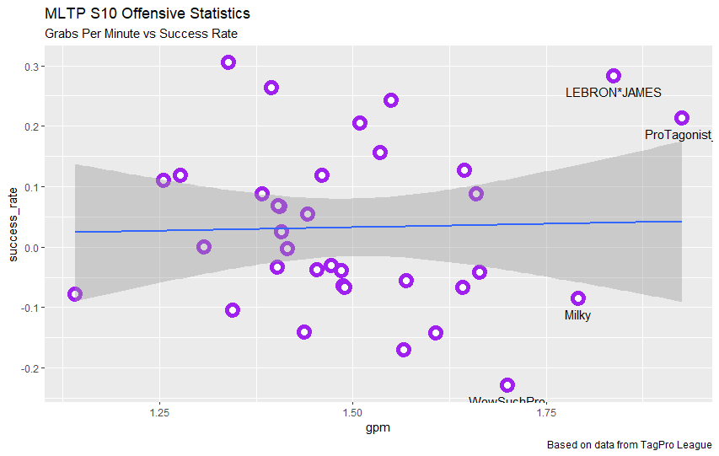

A grab is defined as a player picking up the opponent’s flag. Somewhat surprisingly, grabs per minute seemed to have almost no correlation to success rate. Intuitively, one might posit that the increased chances to get captures from grabbing more would lead to a higher success rate, but the data does not support this belief.

|  |  |  |  |  |  |
| --- | --- | --- | --- | --- | --- |
| R value | STDEV | Variance | Mean | Min | Max |
| 0.028 | 0.167 | 0.028 | 1.498 | 1.141 | 1.926 |

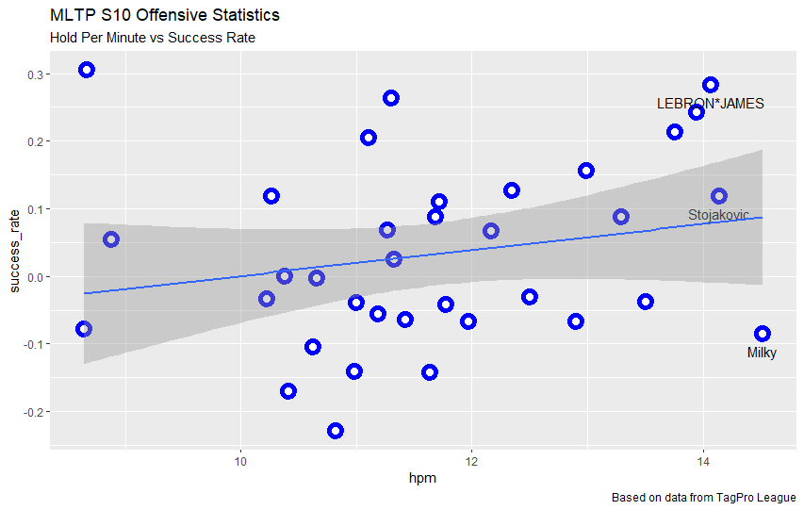

Hold (measured in seconds) is defined as the time that a player had the flag in his possession. Again, somewhat surprisingly, the correlation between hold per minute and success rate is considered very weak, especially considering that the opposing team cannot capture if their flag is being held.

|  |  |  |  |  |  |
| --- | --- | --- | --- | --- | --- |
| R value | STDEV | Variance | Mean | Min | Max |
| 0.214 | 1.517 | 2.302 | 11.661 | 8.645 | 14.518 |

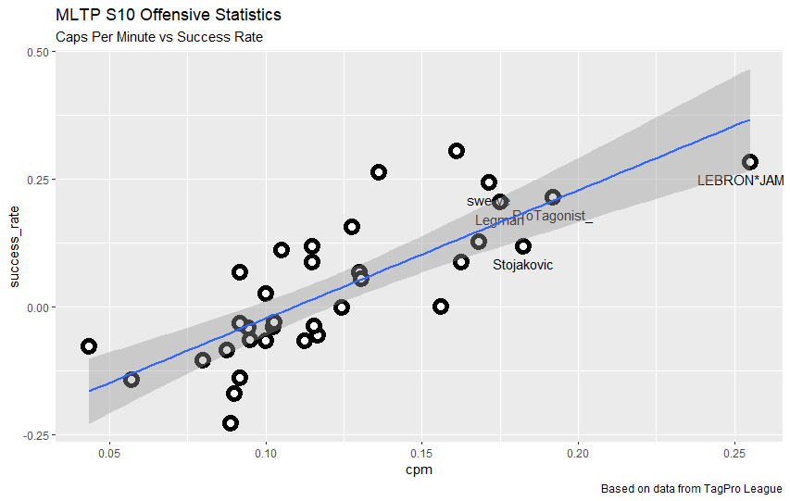

A capture is defined as a player grabbing the flag from the opponent’s base, bringing it across the map back to his own base, and subsequently touching his own flag tile while his team’s flag is at home. As expected, there is a strong correlation between captures per minute and success rate. Since captures are one of the two variables directly used to calculate score differential (the other being captures against), it should be obvious why the correlation here is so strong.

|  |  |  |  |  |  |
| --- | --- | --- | --- | --- | --- |
| R value | STDEV | Variance | Mean | Min | Max |
| 0.778 | 0.042 | 0.002 | 0.122 | 0.043 | 0.255 |

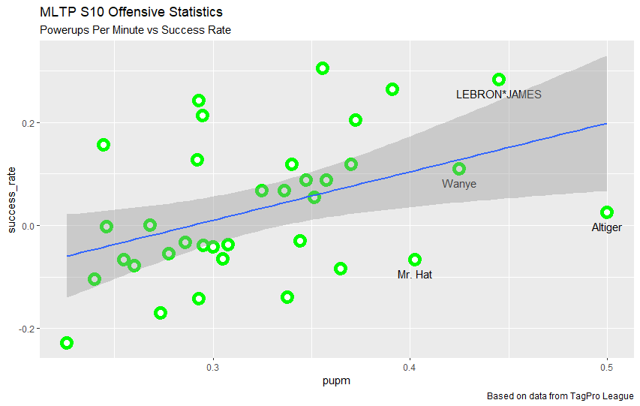

The relationship between powerups and success here is considered weak (0.3 < R < 0.5). The data here suggests that powerups may not play quite as big a role as many players make them out to.

|  |  |  |  |  |  |
| --- | --- | --- | --- | --- | --- |
| R value | STDEV | Variance | Mean | Min | Max |
| 0.428 | 0.062 | 0.004 | 0.323 | 0.226 | 0.500 |

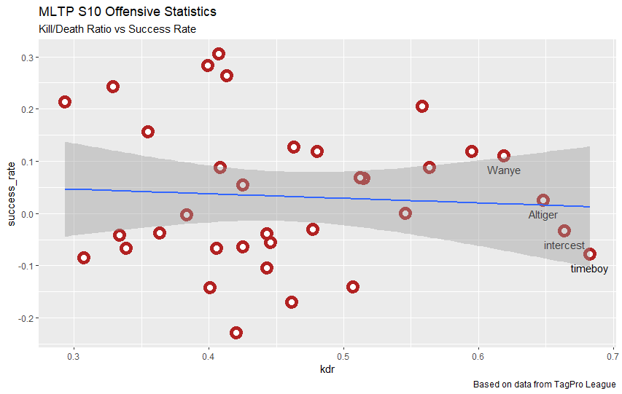

There was apparently almost no correlation between KDR and success rate; in fact, it was actually a very, very weak negative correlation. Although KDR shouldn’t matter as much for attackers as it should for defenders, the fact that the correlation between KDR and success is so low seems counterintuitive. Surely dying less means more time for playing offense and more chances to score?

|  |  |  |  |  |  |
| --- | --- | --- | --- | --- | --- |
| R value | STDEV | Variance | Mean | Min | Max |
| -0.065 | 0.102 | 0.010 | 0.458 | 0.293 | 0.683 |

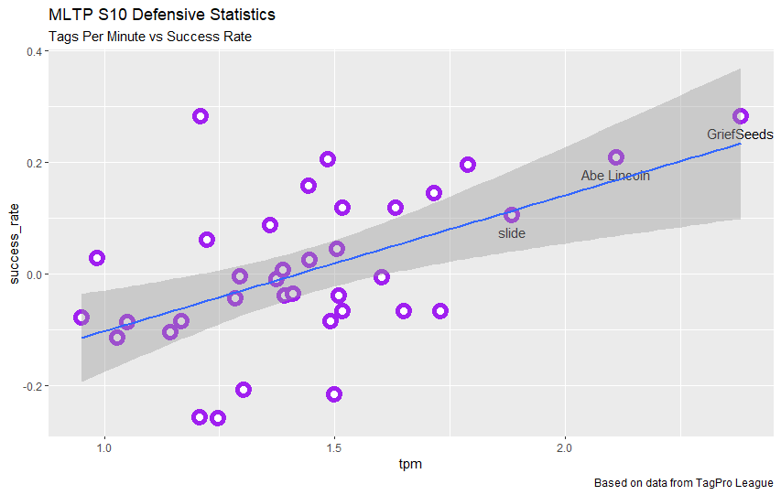

A tag is defined as popping (killing) another player’s ball. There is a moderate, positive, linear relationship between tags per minute and success rate. This is to be expected, as removing the opponent’s players from the action more often should allow a team to outperform the opponent more easily.

|  |  |  |  |  |  |
| --- | --- | --- | --- | --- | --- |
| R value | STDEV | Variance | Mean | Min | Max |
| 0.526 | 0.300 | 0.090 | 1.443 | 0.951 | 2.382 |

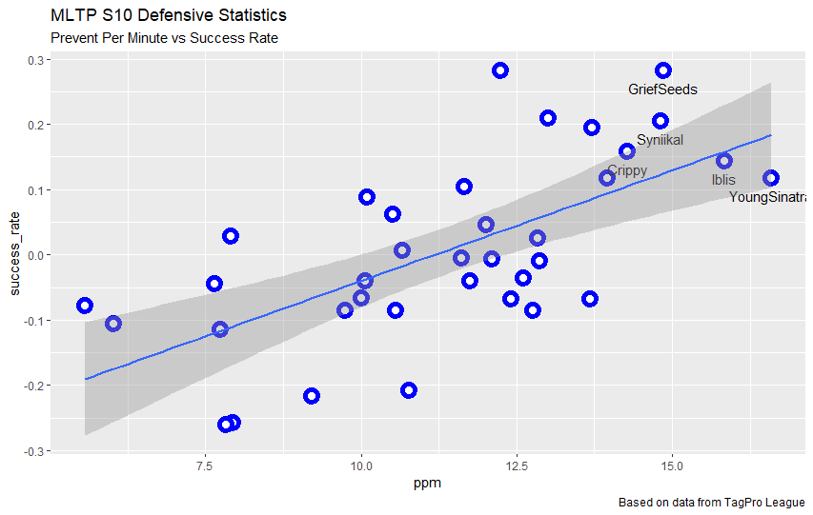

Prevent is defined as the number of seconds that a player was near their own flag tile while one or more opposing players is also close to their flag tile and the flag is at home. A moderate, positive, linear correlation appears between prevent per minute and success rate, which can be attributed to the fact that while one team is preventing, it is impossible for the other team to score but the preventing team is able to score if they have the flag.

|  |  |  |  |  |  |
| --- | --- | --- | --- | --- | --- |
| R value | STDEV | Variance | Mean | Min | Max |
| 0.653 | 2.678 | 7.173 | 11.333 | 5.569 | 16.593 |

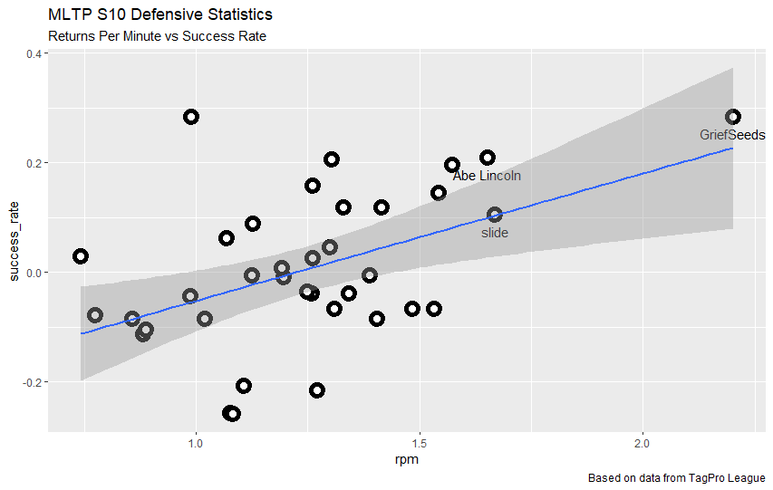

A return is defined as tagging an opposing player when they have the flag in their possession. Returns per minute and success rate have a correlation bordering between weak and moderate, which can be explained by the fact that the more often a player returns their flag to base, the less likely they are to get scored on and the less field presence the other team will have.

|  |  |  |  |  |  |
| --- | --- | --- | --- | --- | --- |
| R value | STDEV | Variance | Mean | Min | Max |
| 0.482 | 0.288 | 0.030 | 1.247 | 0.743 | 2.203 |

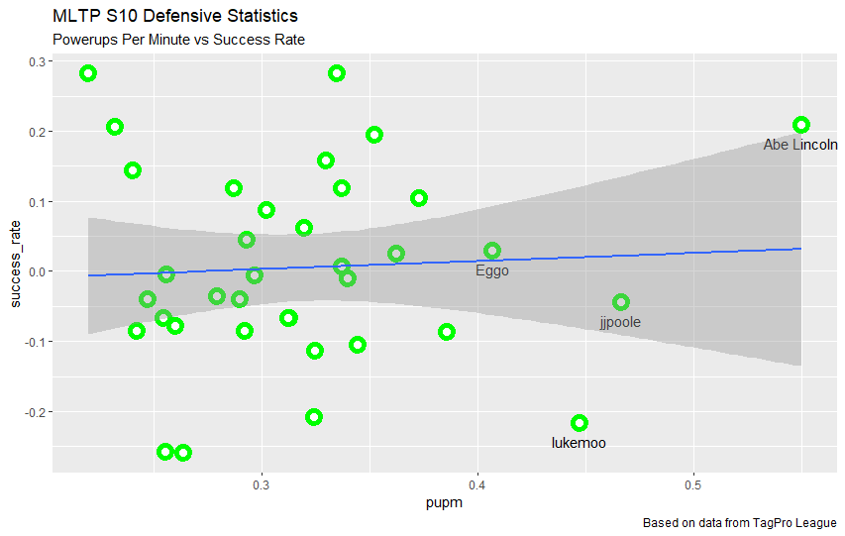

Powerups are special items that spawn in certain places every 60 seconds on maps and confer extra abilities upon the wielder for up to 20 seconds. There is almost no correlation at all between defenders getting powerups and how much success they are having on the score board. Many players would find this surprising, even MLTP players, but the rationale for this is relatively easy to understand for the critical thinker with a good understanding of capture the flag fundamentals. If defenders are leaving the base to get these powerups, then they are leaving the base unguarded and the opposing team can grab their flag uncontested, largely neutralizing the benefit gained from getting the powerup.

|  |  |  |  |  |  |
| --- | --- | --- | --- | --- | --- |
| R value | STDEV | Variance | Mean | Min | Max |
| 0.058 | 0.070 | 0.005 | 0.319 | 0.220 | 0.550 |

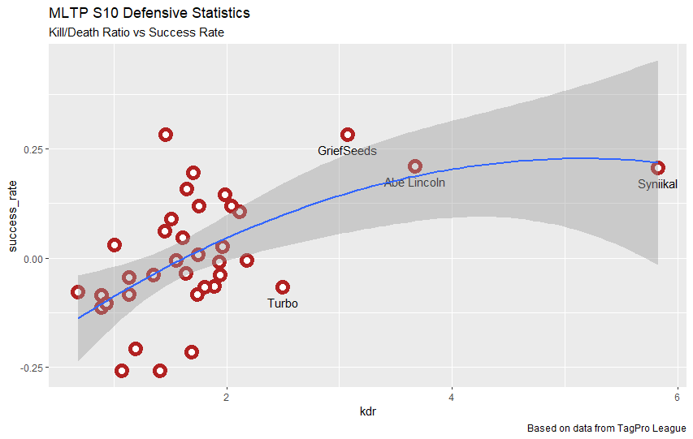

KDR for defensive players is the only variable examined that didn’t have either a linear relation or no relation compared to success rate, but rather a logarithmic relation. Staying alive and getting more tags (the factors in KDR) both increase a player’s success rate with a moderate positive linear correlation by keeping the defender on the field longer so they may protect their base, or killing opposing players to remove them from the action temporarily. However, beyond a certain point reducing a player’s death count increases the player’s KDR by significantly more than it would for a player with more deaths to start with. As an extreme example, a player with 400 tags and 200 pops reducing their pops by 10 would change their KDR from 2.0 to 2.105, but a player with 400 tags and 20 pops reducing their pops by 10 would change their KDR from 20 to 40, despite reducing their time spent dead by the same amount.

|  |  |  |  |  |  |
| --- | --- | --- | --- | --- | --- |
| R value | STDEV | Variance | Mean | Min | Max |
| 0.519 | 0.912 | 0.831 | 1.784 | 0.683 | 5.824 |

Summary of Season 10

For attackers, the captures and powerups were the two most important stats for success by a large margin. Hold had some positive weight as well, but KDR and grabs had basically no impact. For defenders, prevent had the strongest correlation with success, followed by tags, returns, and KDR at approximately the same levels of importance; powerups had effectively no impact on the success of defenders.

Conclusion

Based on the numerical and graphical analysis, there is evidence of which areas players in each position should focus on improving if they would like to improve their success rate. For offenders, controlling the powerups and capturing the flag were the two most important statistics. Directly scoring the flag will obviously lead to a better success rate, and getting powerups both makes a team stronger and denies the opposition the chance to become stronger, so it comes as no big surprise these two categories come out on top. Many players believe more hold is very good, but the stats show that the correlation between holding and winning is weak. While having the flag does allow a team to exert control over the map more easily, if a player is getting a very high amount of hold, it usually means that the other team is also out of base with the flag a lot and the defenses can’t get a reset, which means neither team can score. Additionally, when a player grabs and gets out of base, often his or her best chance to score will be in the first 5 or so seconds, because the defenders chasing from behind will quickly catch up if the flag carrier cannot score quickly and has to circle around and back out of his base for space. So players who get clean grabs past both defenders and come into their own base with good blocks established will not have high hold numbers, due to the efficiency of their captures. Grabs per minute had practically no correlation to success rate. While getting more touches on the flag does generate more chances to get out of base and thus more chances to score, it does also generally increase the number of times a player will be dead, so while more caps are scored with more grabs, more caps are also allowed for the other team. KDR also had practically no impact on the success rate of offenders. How can this be explained, if we believe that dying more is suboptimal? Well, there are two reasons why an attacker could have a higher KDR than his peers: He is dying less than they are, or he is getting more tags than they are. While both of these may seem like good things on the surface level, if attackers are getting a high amount of tags, it means that their defense is both letting the flag out of base and that the defense cannot get the tags themselves, forcing the offense to play very cautiously and assist the defense in chasing the flag carrier or guarding against the other team capturing by staying near the enemy flag tile. So the two factors that influence attacker KDR are most likely cancelling each out in totality and leading to a neutral effect as a whole.

For defenders, prevent had the highest correlation with success rate, which makes sense. If the defenders were able to play “perfectly” and never allow a grab, they would have maximum prevent and would be unable to lose due to having zero caps scored against them. Keeping the flag in base takes a lot of pressure off of the offense, and stops the other team from getting map control very easily. Tags, returns, and KDR are all around the same correlation with success rate, because they are all basically descriptors of slaying power and ability to reset the flag. Being able to bring the flag home to get back to preventing would naturally be the second most important thing, if preventing is the most important. Getting powerups had almost no impact on defenders’ success rates, since the powerups are generally positioned in such a way that for a defender to get them, they must cede protection of the flag, so giving up a grab and missing out on the prevent is cancelling out the ability boost from the powerups. In general at the elite level, attackers control the pace of the game and get to have a greater control of the powerups than the defenders.